Feeling a bit fed up?
We have been in ‘lockdown’ for quite a while now and perhaps some of us are starting to miss school, miss our friends, miss going to the park...
So I thought it would be nice this week to pause, to take some time to think about all the things we are thankful for and remember the good times; as well as taking some time to look forward!
In Psalm 103 v 2 it says – ‘Let all that I am praise the Lord; may I never forget the good things he does.’ Times are hard just now, but we must never forget the good things God has done for us.
Memory Verse
Try to learn Psalm 103 v 2 off by heart. Start off by writing it out on a big bit of paper. Read it and then cross one word out. Read it again and then cross another word out....keep going until you have all the words crossed out and the memory verse is firmly in your head! You could do quiet voices, loud voices, funny voices, read whilst standing on one leg, read with one eye closed etc....just to make it a bit more fun, as you try to learn it.

Write it out and stick it up!
Copy Psalm 103 v2 out onto a piece of paper and decorate it nicely. Stick it up somewhere where you will see it. When times are hard this will remind you to pause and to remember all the good things God has done for you!
Thankful Flower
Draw a beautiful flower. In the centre write, ‘Thank you God for the good things you have done.’ On each of the petals write/draw something that you are thankful to God for. E.g. you might have friend on one petal, food on another etc. Once you have finished say a wee prayer thanking God for all the good things he has done for you.
Memory Game
Sometimes we forget things! Sometimes we forget all that God has done for us...so we need to take time to remember! How is your memory? My memory isn’t great but I love this memory game.
Place 10 objects from your house on the table/on a tray. Take 5 minutes to sit and look at the objects. After 5 minutes cover the table/tray with a cloth, so that no one can see the objects. See how many objects you can remember – you can do it individually or as a family group – you could take it in turns to name one thing each and see if you can get all 10? Or each individual person could be challenged to see how many they can remember. You can play it again and again – simply by taking it in turns to choose a different selection of objects.
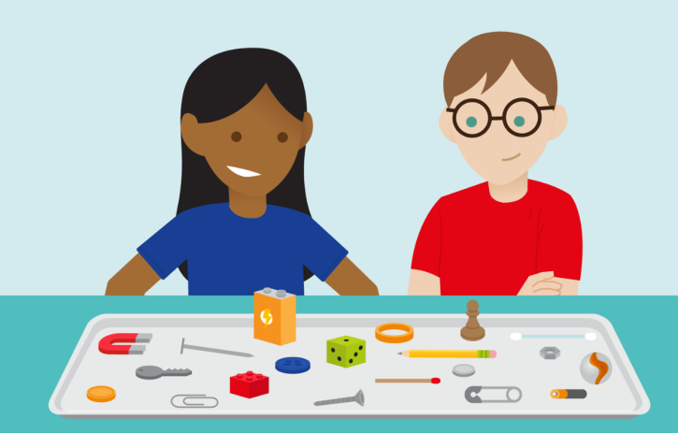

Looking forward Rainbow
Draw a rainbow or use the template that I have attached. Think and talk about the things you are looking forward to, once we get out of lockdown. Write each thing on a different section of the rainbow and decorate. God has good plans for his people – we read about this in Jeremiah 29:11.
God said this to the people in the Old Testament many years ago ; but it is true for us today as well - ‘I know what I’m doing. I have it all planned out – plans to take care of you, not abandon you, plans to give you the future you hope for.’ MSG
How about you write this beautiful verse next to your rainbow?

Have a good week everyone, Love Ruthie x

